Q1 What is software? What is software engineering?

Ans\* Software is a set of instructions, data or programs used to operate computers and execute specific tasks.

\*Software engineering is the branch of computer science that deals with the design, development, testing, and maintenance of software applications.

Q2 • Explain types of software

Ans\* two types of software ▸ System Software

▸ Application Software

▸ System Software

• The programs directly related to the computer hardware and perform tasks associated with controlling and utilizing computer hardware

▸ Application Software

• An application is a job or task a user wants to accomplish through a computer.

• Application software are programs that help a user perform a specific job.

Q3 • What is SDLC? Explain each phase of SDLC?

Ans\* he software development lifecycle (SDLC) is the cost-effective and time-efficient process that development teams use to design and build high-quality software.

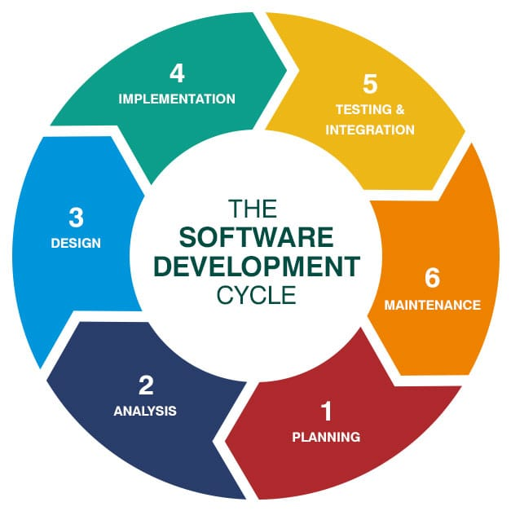

\*Planning: This phase involves defining the project scope, identifying stakeholders, and creating a project plan.

\*Requirements gathering and analysis: This phase involves gathering and understanding the needs of the users and stakeholders.

\*Design: This phase involves creating the software architecture and designing the user interface.

\*Development: This phase involves coding the software and testing it.

\*Testing: This phase involves testing the software for functionality, performance, and security.

\*Deployment: This phase involves deploying the software to production and monitoring its performance.

\*Maintenance: This phase involves fixing bugs and adding new features to the software.

Q4 • What is DFD? Create a DFD diagram on Flipkart?

\*Ans A data flow diagram (DFD) maps out the flow of information for any process or system.

=leval 0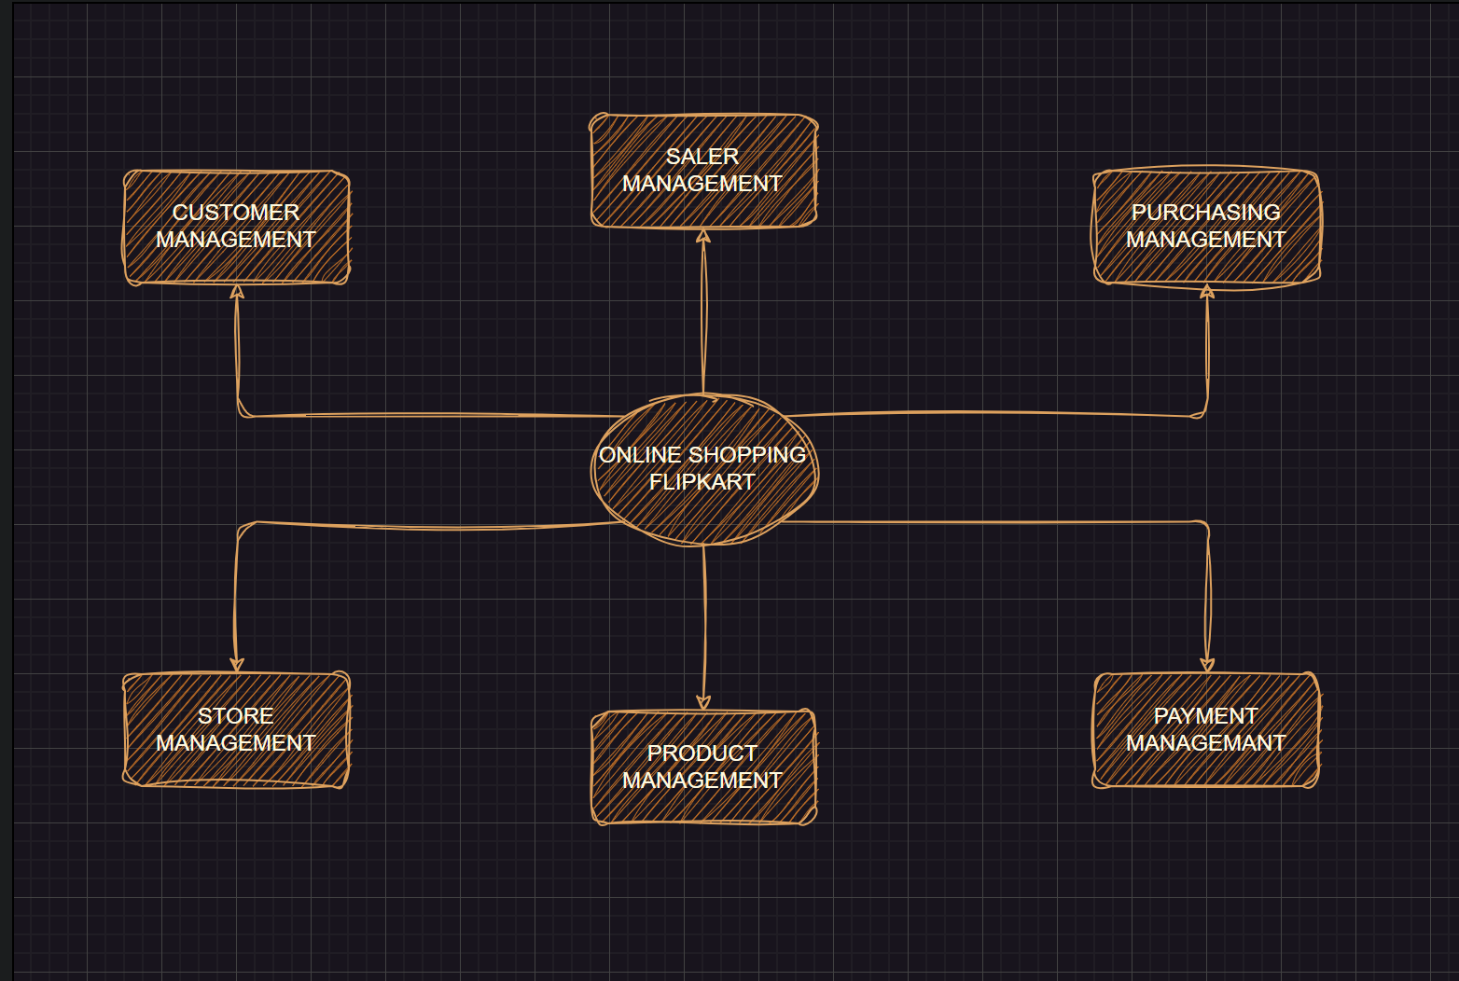

=leval 01

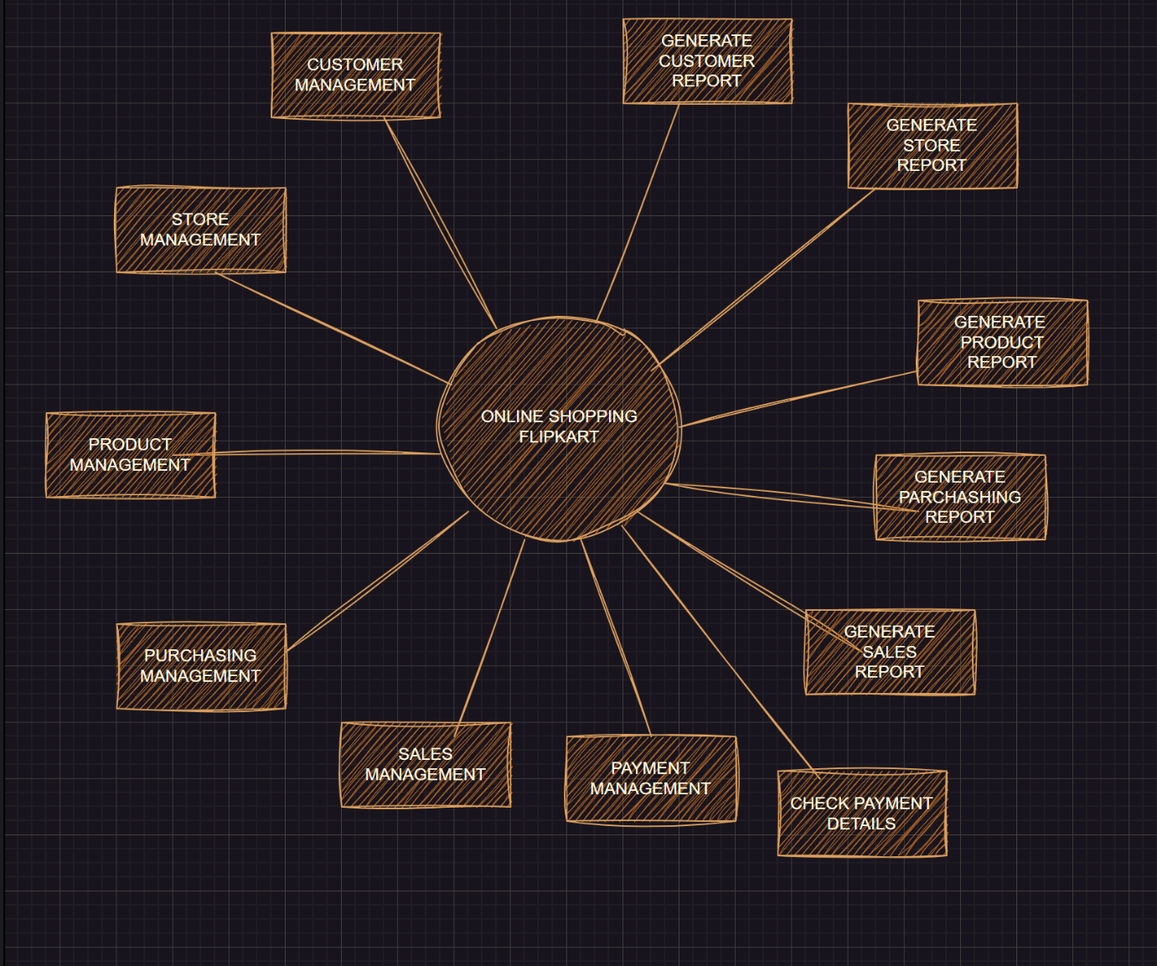

=leval 02

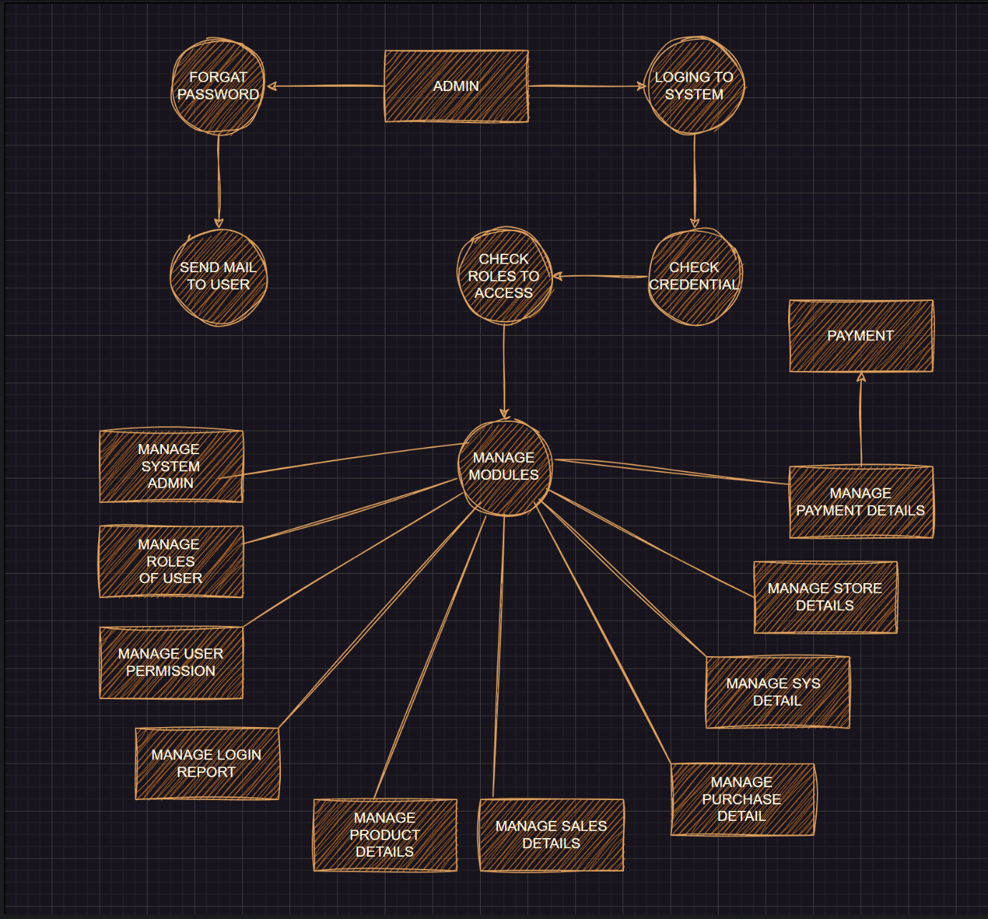

Q5• What is Flow chart? Create a flowchart to make addition of two numbers?

\*ANS= Overview. A flowchart is a type of diagram that represents an algorithm, workflow or process.

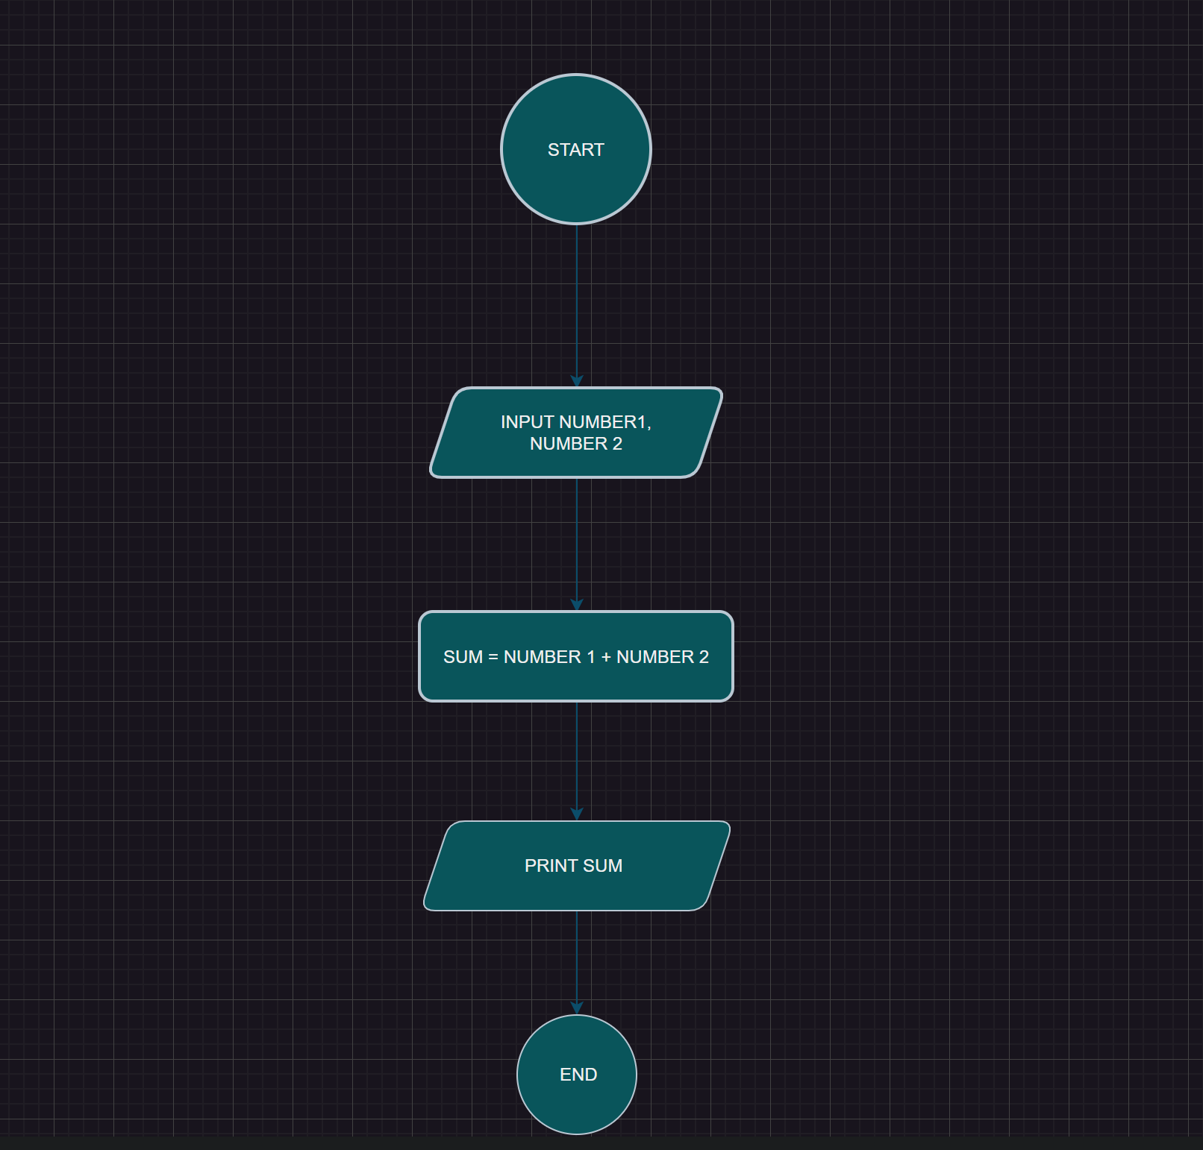

Q6 • What is Use case Diagram? Create a use-case on bill payment on paytm.

ANS=\*Use-case diagrams describe the high-level functions and scope of a system.

